**Prototype Description**

Our prototype was built using the Bootstrap web framework to allow for easy customization in how we want our interface to look. Bootstrap also has built-in classes to quickly create different aspects in our interface. With such limited amount of time to create an entire web system, having quick access to advanced features to create a good-looking interface is important. Not only does Bootstrap offer great customization in a speedy fashion, but also the ability to scale the interface to meet different size requirements. This is important in ensuring our interface meets some layout and navigation principles. This also touches upon some design principles such as, simplicity and flexibility. Our system is flexible because it allows the user to see our entire web site from a tiny screen on their phone without having to horizontally scroll through the desktop version of our interface. Also, being able to use our website on any device is an example of how our interface follows the simplicity design principle.

The major features that were mostly exposed in our interface were the Course Catalog and Course Registration aspects of our system. This is because these two features are the most important functions in making our system functional and meeting the efficiency usability goal. Therefore, these two features should be the first to undergo high-fidelity prototyping to allow more time to develop these features fully.

**Course Catalog**

The Course Catalog system closely resembles what was shown in our sketches of our interface. This is because many of our users who tested the paper-prototype of our registration system liked the features of the Course Catalog. Features such as, being able to compare multiple courses and seeing a visual representation of a course and its pre-requisites seemed very helpful to the user. We believe that having a lot of visual representations of information is better than just showing a clump of text which will allow the user to better understand what’s going on. Thus, the user will be able to quickly get their tasks done without having to decipher our interface. We believe that this part of our system will be successful because of the utility it offers the user. Not only can the user search for a course using many search filters, but the user can also compare these courses and see it’s pre-requisites all from the same screen. This allows the user to transition between these three functions very quickly which helps the user become more productive.

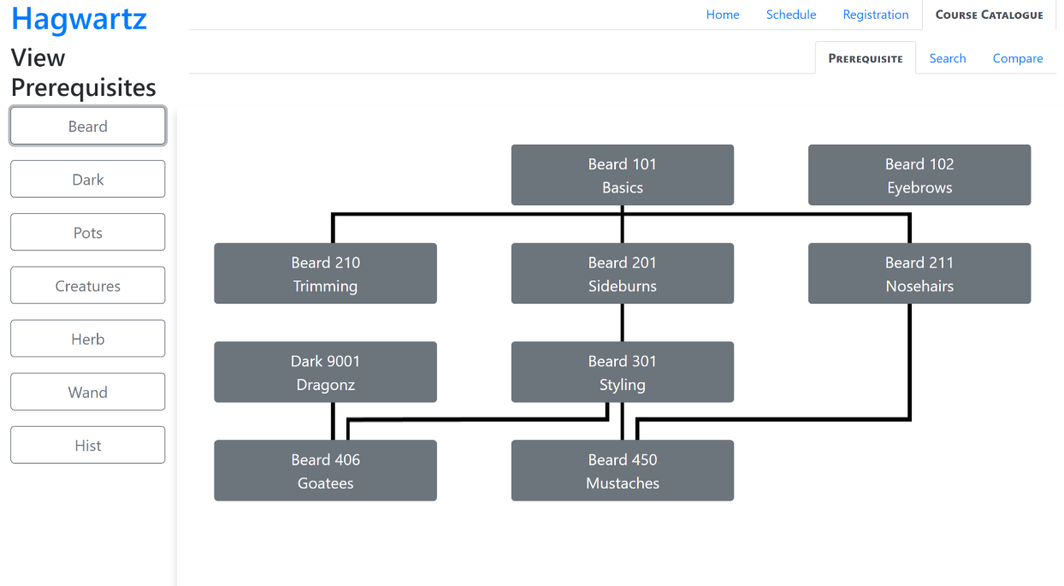

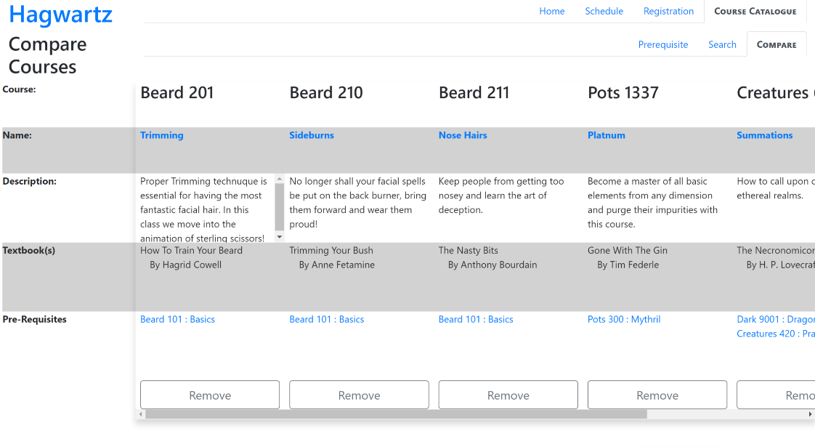

**Course Registration**

The Course Registration aspect of our interface also has many features that were seen with our paper-prototype. It features a visual layout of a student’s course schedule, the ability to add courses to your planner without fully registering for that course, and the ability to test what sections of a course fit within your schedule. When a course is added to your Planner it appears within the Course Registration page. From the Course Registration page, you can select different sections from that course and see how they will fit into your schedule. Depending on which section works with your schedule, you may register for that section and see it appear green on your schedule. There’s a legend on the Course Registration page indicating the status of your courses depending on the colour. This ties into the mapping design principle and how we’re leveraging that to help the user understand our system. We also have used the safety design principle to give users a way to change their actions in the form of a confirmation message when dropping a course.

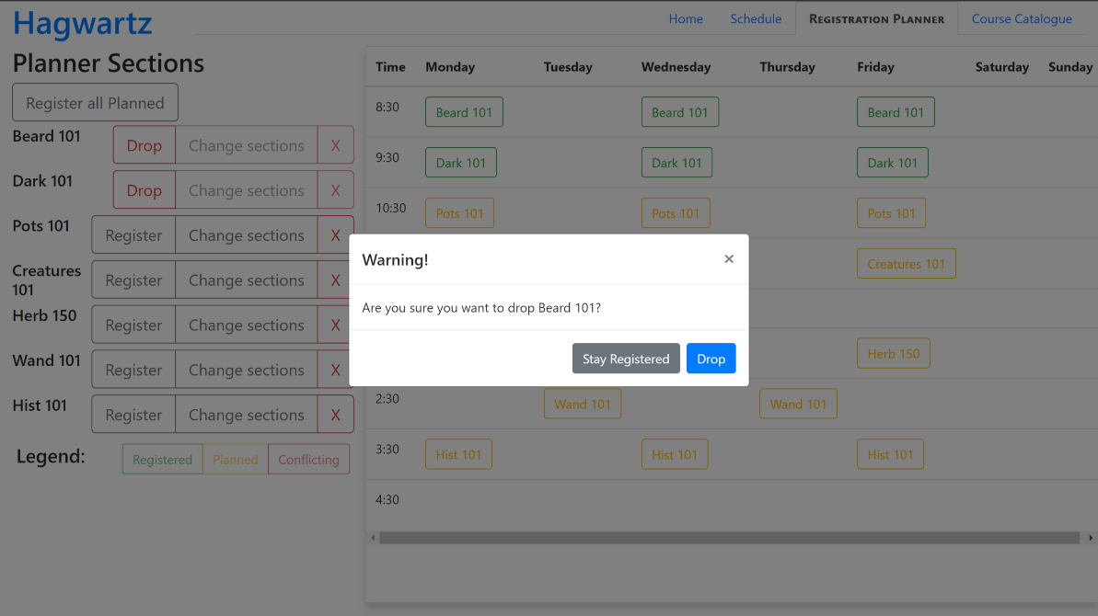

**Bugs**

There are a few minor bugs that are in the Course Registration and Course Catalog aspects in our system. A bug that’s in the Course Catalog is when you try to see the pre-requisite tree of some departments, the previous pre-requisite tree does not disappear. Therefore, after clicking all the different departments you’re left with a very long pre-requisite tree.

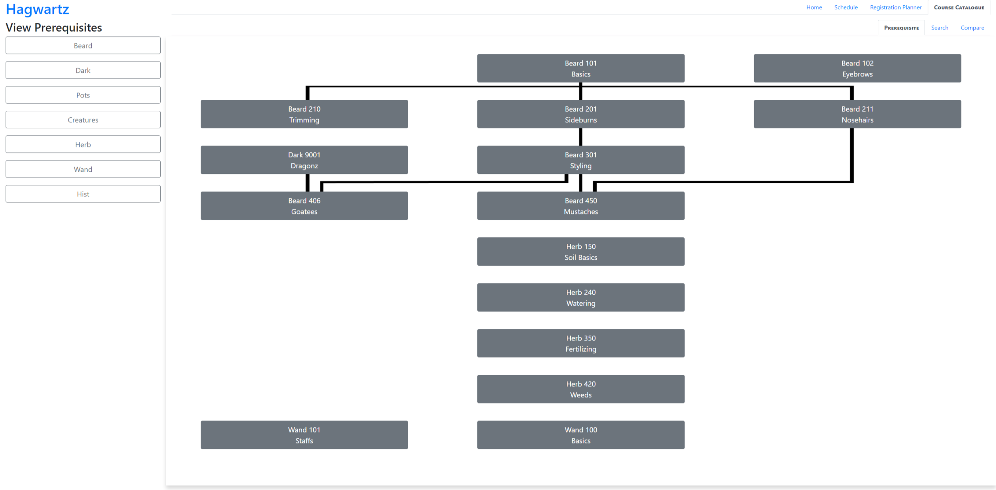

Many of the other “bugs” in our system aren’t really bugs but are more so uncompleted sections. Parts of the system such as the homepage and course schedule are unfinished because it was not the central focus of this prototype. However, some aspects that weren’t finished in the Course Catalog and Course Registration were features that were implemented enough to prove the concept. This is seen in the Course Catalog where most of the search filters match up with the specific courses and are indicated to be apart of that course, but some courses do not. The image below demonstrates a course that doesn’t indicated certain information, such as the number of credit hours.

